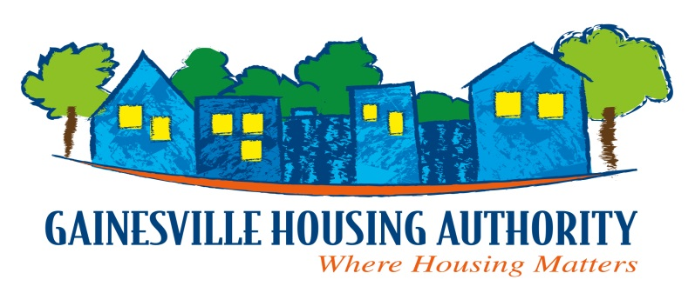
1900 SE. 4th St., Gainesville, FL 32641
Telephone (352) 872-5500 ~ Fax (352) 872-5501
www.gainesvillehousingauthority.org

CHIEF EXECUTIVE OFFICER
PAMELA E. DAVIS

NOTICE OF OFFICE CLOSURES

Due to Hurricane Ian, all Gainesville Housing Authority (GHA) offices will be closed starting Wednesday, September 28, 2022 through Friday, September 30, 2022. We will reopen on Monday, October 3, 2022 as long as the conditions are safe.

GHA follows the guidelines set forth by Alachua County Emergency Management as they become available. Below is a list of emergency numbers for you to use during and after this storm. Please note that our maintenance team will only be able to respond to emergency work orders once it has been deemed save to travel by Alachua County Emergency Management.

EMERGENCY PHONE NUMBERS:
911 For Life-threatening Emergencies in general
352-264-6500 Alachua County Emergency Management
GHA Residents: Non-life-threatening emergencies
352-647-0542 GHA Facilities Manager, Shane Tyler
352-494-5140 GHA Maintenance Supervisor, Clarence “CJ” Williams

